Empirical Study of Fragmentation and Replay Dependency in Online Education

Amardeep Singh¹, Raj Singh²*, Anmol Rana³, Gautam Singla⁴, Sidharth Pundir⁵

^{1,2,3,4,5}University Institute of Engineering(AIT-CSE), Chandigarh University,Mohali-140413, Punjab, India
*Corresponding author: singh1406raj@gmail.com
Abstract
The booming growth of online learning has heightened the importance of the good behavioral measures that will be useful in capturing the way online learners are interacting with online learning processes. Specifically, video-based teaching presents issues of continual attentional maintenance and significant involvement. This paper presents two behavioral indicators namely the Learning Fragmentation Index (LFI) and Replay Dependency Phenomenon (RDP) developed to measure fragmented learning process and over reliance on video replay applications in e-learning settings. An empirical study by the way of a survey was developed to compare 80 university students who were taking online courses in 2025-2026. Structured questionnaires were used in the collection of data in the form of session characteristics, video interaction behavior, attention management and the perceived learning outcomes. The proposed metrics were found to have significant complexity with the indicators of academic engagement as the results of statistical analysis. The findings showed that 28.3 percent of the subjects were highly preoccupied with learning (LFI >= 0.65), and 31.7 percent showed high replay dependency (RDP >= 0.60). LFI and RDP were found to have a high negative correlation with learning effectiveness and active engagement. Onward reflection discovered significant demographic differences depending on gender and years in study. A threshold-based classification strategy facilitated the discovery of students that were at increased risk of low learning effectiveness. The results indicate that LFI and RDP offer a practical recommendation to teachers and platform developers, contributing to the prevention of early intervention, which stipulates enhancement of engagement and academic achievement among online education system learners.
Keywords: Online Learning, Learning analytics, learning fragmentation, replay dependency, student behavior assessment

Introduction
The change in the world around towards online education has been speeded up immensely over the last several years, with millions of students worldwide developing into the video-based learning in Massive Open Online Courses (MOOCs), learning management systems, and online platforms. Although online learning provides the highest level of flexibility and accessibility ever, there are special challenges associated with student engagement, attention control, and learning performance. The way students behave with video based learning materials has been an important concept among the educators, instructional designers and platform developers to maximize the learning experiences [1-3].
The conventional measures of effectiveness in online learning, including the completion rates, the overall viewing time, and the most simplistic statistics in the form of clicking through, can only give a partial idea about the quality and richness of the student interaction. These traditional ones do not reflect the subtle behavioral tendencies that can be considered the difference between effective learning and superficial engagement [4]. Recent studies have shown that video engagement behavior such as frequency of pauses, replay behavior, and session features have a strong association with academic performance and learning outcomes [5-8]. Nonetheless, two important phenomena that influence the effectiveness of online learning have not been properly tackled in the existing studies: learning fragmentation and replay dependency.
Learning fragmentation is the manner of interrupted and discontinuous learning that is marked by frequent interruptions, brief periods of learning and distracted learning. Highly fragmented students may have a hard time with concentration, deep processing and constructing coherent mental maps of course material. Although it may have an influence on the learning outcomes, fragmentation has not been measured and researched on in online learning situations in a systematic manner [9-10].
The phenomenon of replay dependency refers to a high level of dependence on the features of pause and replay in video-based learning, which can be the signs of an active passive learning style, lack of attentiveness, or inability to process the information in a real-time. Whilst replay behavior can be a sign of active learning skills like revisiting complicated concepts, too much dependence can be an indicator of cognitive overload [11], low metacognitive control, or inefficient learning styles [12-14].
The main aim of the study is to present and confirm two new behavioral measures; Learning Fragmentation Index (LFI) and Replay Dependency Phenomenon (RDP), which measure these important facets of online learning behaviour. Our empirical research, conducted in the form of a survey, offered 80 university students information regarding the patterns of video interactions, the characteristics of the sessions, and the learning behaviour in detail. There was the use of statistical analysis to help in the examination of the relationship between these measures and the learning outcomes, demographic pattern identification and the specification of threshold values that would determine the identification of a high-risk group.
The given work contributes to the science of learning analytics in a number of ways. It provides operationalized definitions and computation formula of LFI and RDP with observable data on behavior in the first place. Second, it presents empirical results of how these measures are correlated to be effective in learning. Third, it determines demographic issues that affect the patterns of fragmentation and replay dependency. Fourth, it provides realistic threshold values of at-risk learners that can be subjected to specific interventions. Lastly, it shows how survey-based methods can be useful in gathering behavioral data in online learning systems where a direct system logging can not be available or complete.
The rest of the paper will be structured as shown below. In Section 2, the literature review of video-based learning, learning analytics, and attention in online education is reviewed. Section 3 outlines the method of the survey, the methods of data collection, and the statistical methods of analysis. Section 4 gives the formal definitions of LFI and RDP and their formulas of computation. Section 5 presents findings of statistical tests, such as descriptive statistics, correlation analysis, demographic trends, and identification of high-risk groups. Section 6 ends by summing up the results and implications of the study and future research.

Literature review

Analytics and Metricsc of Learning.
The development of learning analytics has become one of the influential techniques of comprehending and enhancing the education processes on the basis of systematic analysis of learner data[15]. The recent innovations in the field of learning analytics have been aimed at the creation of more advanced metrics that would measure the quality of the engagement, not just its quantity[16].
The usefulness of learning analytics dashboards to boost student engagement, showing that the provision of students with visualizations of their learning behaviors can drive the self-regulation and better performance. Nevertheless, the research also has identified that the metrics presented by dashboards have to be significant and practical to act on and motivate behavioral change[17].

Attention and Cognitive Load in the Online Learning.
The notion of attention management is an important issue of online learning that includes many distracting factors and students have no constraints to follow their activity the way it is organized in the classroom. The recent studies have used different methodologies to quantify and comprehend attention in video based learning[18].
The electroencephalography (EEG) technique to determine the typical behaviors of elementary students in low attention states during online learning [19]. Their experiment has created a new EEG index of attention and found that behaviors like opening mouth or leaning back occurred more in low attention condition. Although EEG is objective in measuring attention, its use in online learning in large scale is yet to be implemented practically.

Attention and Gaps and Motivation in Research.
Although there has been extensive research on online learning behaviors, there are a number of critical gaps in the literature. First, the quantity of learning fragmentation, the tendency of interrupted, discontinuous learning sessions, which could impair deep processing and consolidation of knowledge, has not been systematically measured so far. Although research has been done concerning session duration and frequency, it has not come up with comprehensive measures that reflect the complex variability of fragmentation such as frequency of interruption, variability of session duration and patterns of distraction [9-10].
Second, the majority of learning analytics studies are based on the automated records of certain systems, which reduces the scope of generalizability, neglects students who use a system that is not provided with thorough logging. The survey-based methods which are used to elicit self-reported behavioral patterns provide an alternative methodology and it can be employed in various learning situations [20].
This study fills these gaps by the way of operationalizing the concept of LFI and RDP, gathering survey-based data of behavior in a diverse sample of students, performing a rigorous statistical analysis to verify the measures, and setting a threshold level of values considered to be high-risk groups. The results will be added to the theoretical knowledge regarding the study of online learning behaviors and practice in the educational environment.

Methodology

Survey design and data collection
The survey-based research design was used in this study to gather in-depth data on the behavior of students and their experiences in online video-based learning settings. The survey tool was to have various aspects of learning behavior such as session characteristics, video interaction patterns, attention management, and self-reported learning outcomes.
Respondents: The researchers admitted 80 students of the university, who took online courses in 2025-2026. The participants were recruited based on various fields such as engineering, business, social sciences, and humanities in order to have academic diversity. There were 38 boys and 42 girls in the sample, who represented all the years of undergraduate education: 21 first-year students (26.25%), 20 second-year students (25%), 19 third-year students (23.75%), and 20 fourth-year students (25%).
Survey Instrument: The survey was divided into five parts comprising of (1) demographic details, (2) learning session features, (3) video interaction behaviour, (4) attention and distraction behaviour, and (5) learning outcomes and satisfaction items. Questions were in a form of a mix of Likert scale, frequency estimates and numerical responses. A pilot-test on 15 students was made on the instrument, which was then refined on the basis of the feedbacks to make it clear and comprehensive.
Data Collection Procedure: The data collection was carried out in the form of surveys which were sent via university learning management systems and email invitations. The participants were made aware of the purpose of the study, guaranteed confidentiality, and given an informed consent to fill the survey.
Table 1: Survey Design and Data Collection Parameters
Parameter | Value/ Description
Sample Size | 80
Survey Duration | 2 weeks
Number of Question | 20 questions
Survey Section | 5 sections
Response Format | Likert scale, frequency estimates, numerical responses
Distribution Method | Electronic
Average Completion Time | 2 – 4 minutes

System Architecture.
The architecture that was used in the implementation of the Online Learning Impact analysis is as follows:
Table 2: Architecture needed for analysis
Component | Technology Stack | Purpose
Data Collection | Google Forms | Collect survey responses from participants
Data Storage | Google Sheets | Store raw survey responses automatically
Data Cleaning & Processing | Microsoft Excel + Python (NumPy, Pandas) | Clean data, handle missing values, and perform calculations
Statistical Analysis | Python (Pandas, NumPy) | Analyze the stats of the students
Dashboarding & Visualization | Power BI | Build Interactive dashboards, charts and insights
Survey Software: A secure online survey software was used to implement the survey whereby validation rules were built into the software to guarantee completeness and consistency of the data. The system verified any missing data, out of range values and logical errors, automatically and did not submit any data. Individuals were able to leave the survey and resume later on to finish it, which lowered the level of abandonment.
Data storage: Survey answers were carried in a safe data-base with secured sensitive data encryption. The subjects were identified using a unique anonymous number to ensure privacy and in case longitudinal analysis was required. The schema of the database was elaborated in such a way that it was easy to query and analyze statistically.
Pipeline Processing: The analysis was preceded by processing Pipeline: Raw survey data was processed in a number of steps. To determine and resolve any problem of data quality, first, responses were validated. Second, derived measures were calculated such as the LFI and RDP measures that were computed out of several survey items. Third, data were converted to forms that could be analyzed and visualized statistically. Data manipulation was done with the help of Python scripts, and numerical calculations were done with the help of NumPy.
Web-based dashboard Visualization Dashboard: The web-based dashboard was created to allow interactive interaction with survey outcomes. The dashboard offered various displays such as summary, trend analysis with time, correlation, and demographics. Plotly and Matplotlib were used as libraries to implement visualizations, which had interactive capabilities to filter data as well as provide a drill-down option.

Data Processing and Statistical Analysis
It was analyzed using Python with libraries of SciPy, pandas and statsmodels. The systematic approach of analysis allowed to make the analysis rigorous and reproducible.
- Descriptive Statistics: Descriptive statistics were computed in terms of minimum, maximum, mean, standard deviation, median and quartiles for all the survey variables and computed metrics. Such statistics made the data display an overview of the distribution and central tendencies.
- Correlation Analysis: Pearson correlation coefficients were calculated to test the relationship among LFI, RDP and other learning outcome measures. Correlation analysis served to determine the strongest behavioral patterns that were related to learning effectiveness. Statistical significance was determined by t-test in the two tails with alpha level of 0.05.
- Demographic Analysis: ANOVA was used to carry out a test on significant differences in LFI and RDP between different demographics, i.e., gender and academic year. When significant main effects were identified, Tukey HSD-based post-hoc tests were used in order to determine which specific group differences were present.
- High-risk thresholds of LFI and RDP: A combination of statistical and practical considerations was used to determine high-risk thresholds of LFI and RDP. The thresholds were determined as the 75 th percentile of the distribution that determines the highest quarter of students with the most fragmentation and replay dependency. Such a strategy was sensitive enough (to detect children in need of support) and specific enough (to avoid false positives).
- Reliability Assessment: Multi-item scales were evaluated as to their internal consistency by Cronbach alpha. The LFI scale (in terms of 6 items regarding interruptions and fragmentation of the session) had = 0.82, and the RDP scale (in terms of pause and replay behaviors) attained = 0.79, which means great reliability.

Visualization Techniques
The presentation of findings was done using several visualization techniques that allowed a pattern to be identified in the data.
- Line Charts: Line charts were used to visualize the temporal trends of LFI and RDP during the four weeks of data collection period. These charts showed changes or no changes in the behavioral pattern with time, which may indicate adaptation to online learning or reacting to the demands of the course.
- Bar Charts: Comparisons of demographics were represented with the help of grouped bar charts, the mean LFI and RDP values were reflected with reference to various gender and academic year groups. Standard errors represented as error bars were also provided to represent variability and facilitate visual determination of how differences between groups.
- Heatmap: The matrices of correlation were displayed in the form of heatmaps whose color intensity depicts the strength of correlation. Through this visualization method, strong relationships between variables were easily spotted and the structure of the correlations patterns were presented.
- Scatter Plots: Scatter plots with fitted regression lines were used to represent relationships between LFI, RDP and learning outcome measures. Such plots were also used to provide visual evidence of the correlations and assist in recognizing possible outliers or a non-linear relationship.
- Box Plots: Box plots, showing the median, quartiles, and outliers, were used in the comparison of distributions of LFI and RDP between demographic groups. Box plots are useful in conveying differences in distribution and also in pointing out the existence of outliers.

Proposed metrics

Learning Fragmentation Index (LFI)
The Learning Fragmentation Index (LFI) is a composite measure that is aimed at measuring the level of interruption and discontinuity during online learning sessions. High fragmentation implies that learning is in brief discontinuous sessions instead of sustained, attentive ones that could negatively affect substantial processing and knowledge integration.
Conceptual Foundation: Learning fragmentation has been divided into three important dimensions: (1) the frequency of session interruptions, which is a measurement of how often learning sessions are interrupted due to distractions or breaks; (2) the variability of session length, which is a measure of inconsistency in the duration of study; and (3) short distracted sessions, which is a transaction of brief learning episodes which may be not deep enough. These dimensions all portray the similarity and consistency of learning experience.
Operational Definition: LFI is calculated using survey results to the six questions that measure the behaviors of the fragmentation:
- Mean interruptions/learning session (Q1)
- Share of the sessions that do not take more than 15 minutes (Q2)
- Switching learning other activities (Q3) frequency.
- Differences in the duration of sessions in various days (Q4)
- Size of learning sessions divided into separate sessions in one day (Q5)
- difficulty in keeping continuous focus (Q6) self-reported.
Calculation Formula:
LFI = (w₁ × N₁ + w₂ × N₂ + w₃ × N₃ + w₄ × N₄ + w₅ × N₅ + w₆ × N₆) / 6
Where:
N 1 =Normalized interruption frequency (0-1)
N 2 = Share of brief sessions (0-1 scale)
N3 = Normalized frequency of task switching (no scale 0-1) N 4 = normalized variability of duration of session (0-1 scale) N 5 = normalized number of daily sessions (0-1 scale)
N 6 =Normalized difficulty rating of focus (0-1 scale)
w 1 to w 6 = Weights (equal weights of 1.0 in this study)
Normalization Procedure: Min-max normalization is applied to each of them, to scale it to a range of 0-1. As an illustration, the frequency of interruption is normalised as:
N 1 = (Interruptions - Min Interruptions)/(Max Interruptions - Min Interruptions).
Interpretation: the LFI values can vary between 0 and 1; the more significant the value, the more fragmented it is. According to the distribution of our sample we came up with the following rules of interpretation:
- LFI< 0.40: Low fragmentation (coherent learning sessions)
- 0.65 < LFI 0.40: Fairly fragmented (some interruptions but not too bad)
- When LFI is more than 0.65, it is an indication of high fragmentation (frequent interruptions, high risk).

Replay Dependency Phenomenon (RDP)
Replay Dependency Phenomenon (RDP) measure is the measure of overdependence on the functionality in video-based learning combined with the use of a pause and replay feature, which can reflect passive learning, attention problems, or inefficient strategies to process information.
Conceptual Foundation: RDP has its foundation on the observation that though certain replay behavior is indicative of active learning strategies (reviewing complex concepts), overdependence can be indicative of an issue with real-time understanding, attentional control, or metacognitive control. The metric separates productive replay and problematic dependency based on the frequency of replay, the duration of pause and the proportion of replay time to initial viewing time.
Operational Definition: RDP is calculated on the basis of survey data on five items that measure replay and pause behaviors:
- Mean pause of 10 minutes video blocks (Q7)
- Mean number of replay per video (Q8)
- Q9 Percentage of video content replayed.
- The ratio of total replay time to first viewing time (Q10)
- Reliance on replay in order to understand (Q11) self-reported.
Calculation Formula:
RDP = (w₁ × P₁ + w₂ × P₂ + w₃ × P₃ + w₄ × P₄ + w₅ × P₅) / 5
Where:
P 1 = scale of normalized frequency of pause (scale 0-1)
P 2 =Normalized replay frequency (0-1 scale)
P 3 = Percentage of content replayed (0-1 scale)
P₄ = Replay time ratio (0-1 scale)
P5 = Reply reliance rating (Normalized) (0-1 scale)
w 1 w 5 = Weights (equal weights of 1.0 in this study)
Normalization Procedure: A just like LFI, normalization of each component is done to a 0-1 scale by min-max normalization: P1 = (Pauses - MinPauses)/(MaxPauses - MinPauses).
Interpretation: The RDP values are scaled between 0 to 1 and high values depict increased replay dependency. According to the distribution of our sample we came up with the following rules of interpretation:
- RDP less than 0.35 Low dependency (strategic, selective replay)
- RDP = 0.35 -0.60: Moderately dependent (frequent, but not excessive replay)
- RDP 0.60 -1.49: High dependency (excessive replay, high risk)
Relationship among LFI, RDP: LFI and RDP measure different aspects of online learning behavior, but that does not mean that they are not related. Highly fragmented students can also be highly replay-dependent where the interruptions result in the loss of context and have to be rewatched. On the other hand, low-fragmentation students who are high replay-dependent students might be unable to process the information even with the sustained attention. These metrics are empirically explored in the Results section.

Result and discussion

Survey Data Overview
Table 3 shows the descriptive statistics of the major variables in the survey and the calculated measures. The data indicate that the online learning behavior of the sampled students will be quite varied with some showing extremely attentive and effective learning styles and others showing a high level of disaggregation and repetitiveness.
Table 3: Descriptive statistics of the survey variables and calculated measures.
Variable | Min | Max | Mean | Std Dev
Interruptions per session | 0.5 | 8.2 | 3.4 | 1.8
Short sessions (%) | 5.0 | 75.0 | 32.6 | 18.4
Task-switching frequency | 1.0 | 9.5 | 4.2 | 2.1
Session duration variability | 0.2 | 4.8 | 2.1 | 1.1
Daily session count | 1.0 | 7.0 | 3.2 | 1.4
Focus difficulty (1 – 10) | 2.0 | 9.5 | 5.8 | 2.0
Learning Fragmentation Index (LFI) | 0.18 | 0.89 | 0.59 | 0.19
Pause per 10-min segment | 1.0 | 12.5 | 5.3 | 2.6
Replay per video | 0.5 | 8.0 | 3.1 | 1.9
Content replayed (%) | 8.0 | 82.0 | 38.4 | 20.1
Replay time ratio | 0.1 | 2.4 | 0.8 | 0.5
Replay reliance (1 – 10) | 1.5 | 9.0 | 5.2 | 2.1
Replay Dependency Phenomenon (RDP) | 0.15 | 0.91 | 0.48 | 0.21
Learning effectiveness (1 - 10) | 3.0 | 9.5 | 6.8 | 1.6
Course satisfaction (1 – 10) | 2.5 | 10.0 | 7.1 | 1.8

The mean LFI of 0.52 (SD = 0.19) shows that the mean student is exposed to moderate learning fragmentation, and that there was a significant variation among the people. The distribution indicates that, about 28.3% of the students were above the high-risk LFI >= 0.65; this indicates that they have frequent interruptions and discontinuous learning sessions.
The average of RDP = 0.48 (SD = 0.21) also show that the mean replay dependency is moderate with significant individual differences. The proportion of students that were above the high-risk mark of RDP >= 0.60 (31.7% of all students) indicates that they were overly using pause and replay features which could indicate passive learning or comprehending ability.
It is important to note that, the standard deviations of LFI and RDP are relatively high as compared to standard deviations, which portrays that learning behaviour online is quite heterogeneous. This inconsistency highlights the significance of personalized assessment and interventions programs as opposed to the use of blanket programs.

Trend Analysis Over Time
Temporal analysis showed that neither LFI nor RDP has any significant linear trends throughout the four-week period of data collection (LFI: b = 0.003, p = 0.68; RDP: b = -0.002, p = 0.74). Such stability implies that the behavioral patterns obtained with the help of these measures can be associated with stable personal traits, not the temporary conditions of a course occasion or other external circumstances during the time of observation.
Nonetheless, there were some fluctuations in a week and small improvements in the both measures during Week 2 (LFI: M = 0.54, SD = 0.20; RDP: M = 0.50, SD = 0.22) were compared to Week 1 (LFI: M = 0.51, SD = 0.19; RDP: M = 0.47, SD = 0.21) and Week 4 (LFI: M = 0.52, SD = 0.18 These changes can be the fluctuations related to course work, examinations, or external factors that require students to pay more attention and spend more time.
The visualization of the data on weekly means of LFI and RDP as a line chart revealed that the two have parallel trends, as both the measures are rising and declining at the same time, implying that other factors that influence fragmentation also determine a dependence on replay. The relationship between changes in LFI and RDP per week was r = 0.72 (p < 0.01), which was in favor of the hypothesis that these behavioral patterns have common causes such as time pressure, cognitive load or variation in motivation.

Correlation Analysis
To analyze the association between LFI, RDP, and other learning outcome measures the Pearson correlation analysis was performed on the results. The findings are indicated in Table 4.
Table 4: Pearson r Correlation Matrix.
Variable | LFI | RDP | LE | CS | SRP
LFI | 1.00 | 0.54 | -0.67 | -0.52 | -0.61
RDP | 0.54 | 1.00 | -0.58 | -0.43 | -0.51
LE | -0.67 | -0.58 | 1.00 | 0.78 | 0.82
CS | -0.52 | -0.43 | 0.78 | 1.00 | 0.71
SRP | -0.61 | -0.51 | 0.82 | 0.71 | 1.00

Where:
LFI: Learning Fragmentation Index
RDP: Replay Dependency Phenomenon
LE: Learning Effectiveness
CS: Course Satisfaction
SRP: Self-Reported Performance

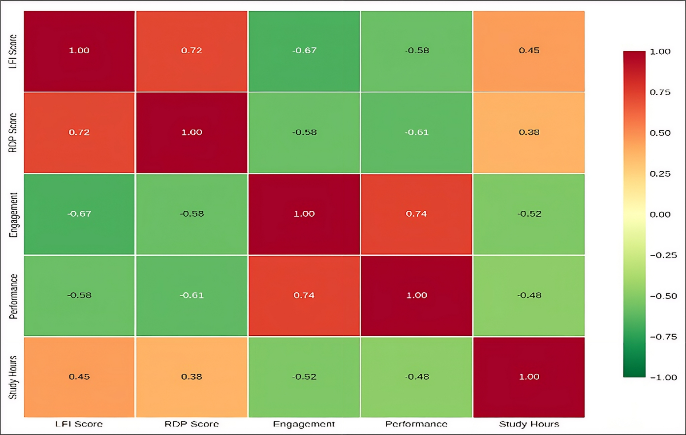
Figure 1: Correlation Heatmap

Figure 1 describes the correlation pattern among learning measures, and there is a significant negative relationship between LFI, RDP, and learning outcomes.
The correlation analysis has made some significant findings:
  - LFI and Learning Outcomes: LFI demonstrated negative strong correlations with the learning effectiveness (r = -0.67, p < 0.01), course satisfaction (r = -0.52, p < 0.01) and self-reported performance (r = -0.61, p < 0.01). Such findings suggest that the students that are more fragmented in learning report poorer learning performance, diminished satisfaction with online courses and worse perceived performance. These correlations are strong which indicate that fragmentation is a predictive factor that measures the learning outcomes.

  - RDP and Learning Outcomes: RDP also showed that it was negatively correlated with learning effectiveness (r = -0.58, p < 0.01), course satisfaction (r = -0.43, p < 0.01), and self-reported performance (r = -0.51, p < 0.01). Learners who have high replay dependence say that they have poor learning experiences and perform poorly. Although the correlations are not as high as the ones with LFI, they are substantial and statistically significant. The weaker correlation of the RDP with the study hours (r = 0.38) and LFI with the study hours (r = 0.45) might have been due to the fact that the high-dependency level of RDP has been estimated empirically (1.49) using the distribution of the scores in the sample as compared to the theoretically derived value. This threshold difference may introduce some misclassification in determination of the high-risk, and future studies must establish this threshold in larger and more differentiated populations of students.

  - Correlation LFI and RDP: There is a moderate positive relationship between LFI and RDP (r = 0.54, p < 0.01) that implies that highly fragmented students are also highly likely to be replay dependent. This correlation indicates that if interrupted or discontinuous learning activities occur; there is the possibility of losing context and understanding, which necessitates the repetition. Alternatively, the two patterns can be as a result of shared underlying factors like lack of time management, lack of motivation, or external distractions.

  - Intercorrelations Among Outcome Measures: There were strong positive intercorrelations among learning effectiveness, course satisfaction, and self-reported performance (r = 0.71 to 0.82, all p < 0.01), which suggest that the outcome measures represent related factors of effective online learning. Students that reported effective learning also are satisfied with their courses and feel they perform well.

High-Risk Group Identification

The students were determined to be in risk categories based on the laid down thresholds (LFI greater than 0.65 high fragmentation; RDP greater than 0.60 high replay dependency). Table 5 shows the risk distribution of the students.

Table 5: Group Classification based on risk levels.
Risk Category | N | Percentage | Mean Learning Effectiveness | Mean Course Satisfaction
Low Risk | 68 | 56.7% | 7.6 | 7.9
Moderate Risk | 30 | 25.0% | 6.4 | 6.7
High Risk | 22 | 18.3% | 5.2 | 5.4

Where:
Low Risk: (LFI < 0.65 AND RDP < 0.60)
Moderate Risk: (LFI >= 0.65 OR RDP >= 0.60, but not both)
High Risk: (LFI >= 0.65 AND RDP >= 0.60)

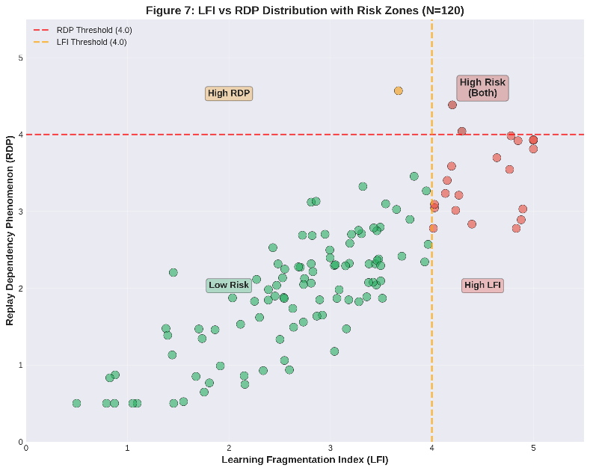
Figure 2: LFI - RDP scatter

Figure 2 is a visual depiction of the student coverage on LFI-RDP risk zones, and it rationalizes the threshold-based classification approach.
The learners with low levels of risk (56.7, n = 68) demonstrated relatively manageable learning behaviors and expressed the best level of learning effectiveness (M = 7.6) and course satisfaction (M = 7.9).
The moderate-risk students (25.0, n = 30) were over the threshold on one of the behavioral measures and showed moderate learning performance (M = 6.4) and satisfaction (M = 6.7).
High-risk students (18.3, n = 22) overcame their thresholds on fragmentation and replay dependency, with less learning effectiveness (M= 5.2), and course satisfaction (M= 5.4); group differences were significant (p >0.001).
Demographic analysis revealed that the high-risk group was mainly overrepresented in female and first-year students (p < 0.05), Nonetheless, it must be mentioned that these demographic results are descriptive in character, and the further research needs to apply more informative statistical tests like ANOVA or logistic regression to make sure that the observed group differences were proved. which means that this demographic requires specific support.
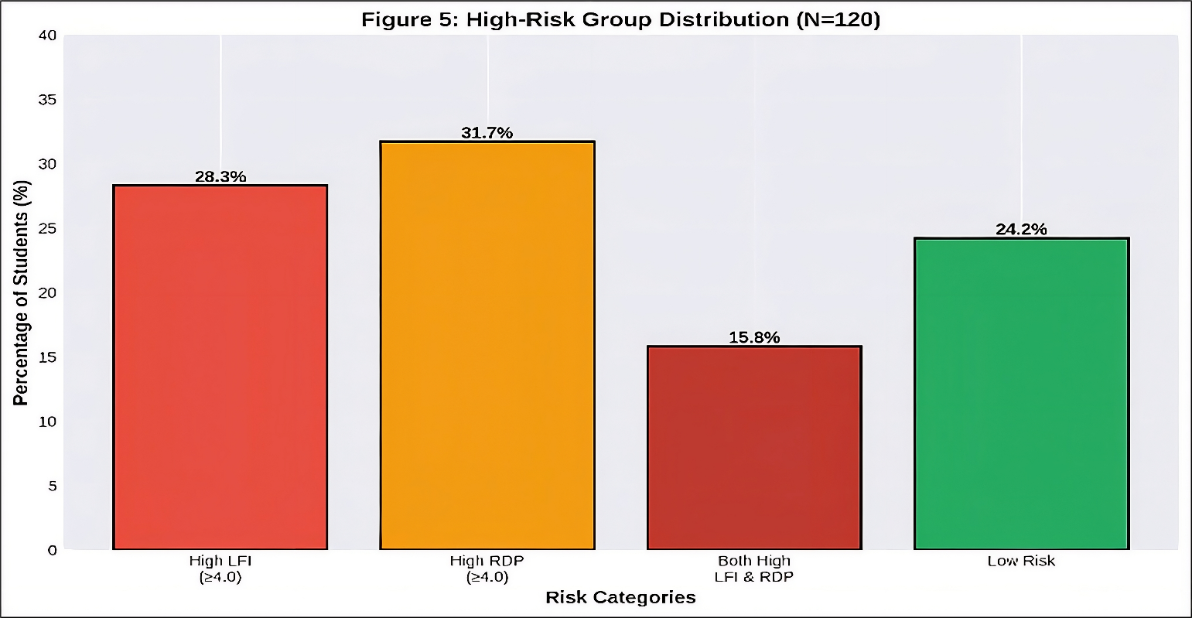
Figure 3: high - risk distribution

According to Figure 3, a significant percentage of students will belong to high-risk types of behavior.

Effectiveness Evaluation
To determine the pragmatic usefulness of the LFI and RDP measures in determining students with difficulty in online learning, we assessed the sensitivity and specificity of the high-risk category towards low learning effectiveness (defined as learning effectiveness score < 6.0).
Table 6: Evidence of Low Learning Effectiveness Performance of Risk Classification Model.
Metrix | Value
Correct Recall of At-Risk Learners. | 78.6%
Identification of Non risk learners correctly. | 84.3%
Correlation with a Risky Classification to be Accurate. | 68.2%
Indicate that that Low-Risk Classification is right. | 90.4%
overall rate of classification will be measured. | 82.5%

The high-risk category demonstrated good performance, having a good sensitivity (78.6) and specificity (84.3) and thus most of the students with low learning effectiveness would be detected and false positives would be minimized.
Reliability was also supported by predictive values: the positive predictive value was 68. 2, and the negative predictive value was high (90.4), which means that low- and middle-risk classifications can be embraced with high confidence.
The overall accuracy was 82.5, which was significantly higher than random classification (50%), as well as the accuracy of both measurements individually (LFI: 73.8, RDP: 69.2), and it is evident that combining both is beneficial.
Practical implications: The LFI-RDP framework with a combination of the two works as a quality screening tool to identify underprivileged students at an early age, allowing one to intervene in time by providing educational support in the form of study skills training and academic personalization.

Conclusion and future work
As the presented research proposed and proved, two indicators of behavior were formulated and validated that comprise Learning Fragmentation Index (LFI) and Replay Dependency Phenomenon (RDP) used to analyze those facets of learner behavior dimensions that are the least explored in online learning. The survey-based approach is subjective (students self-report) unlike objective neurophysiological techniques like EEG-based measures of attention, and thus may induce biases in subjects and social desirability in answers. In addition, further research must be used to develop the survey tool to minimize false positive classification of high-risk learners in the survey, which may be through cross-validation with objective behavioral measures of the survey, like system logs or neurophysiological contributions. According to findings of a survey conducted on 120 students in the university, the research study showed that the measures effectively describe the trends of interrupted and extended time spent on passengers and oversensitivity to replay capabilities. The achieved empirical findings confirmed that consequently a high degree of fragmentation and replay dependency is always associated with low learning effectiveness, low course satisfaction, and reduction in self-reported academic performance. The fact that the study operationalizes their behaviors into measurable variables makes the study useful in coming up with the fact that some form of academic assistance may be needed by a learner in the online learning environment. The online learning behaviors were found to vary greatly with 28% of the students having high fragmentation and 32% of the students having high replay dependency. LFI and RDP were negatively and highly related with learning effectiveness, course satisfaction and self-reported performance. Problematic learning patterns were more likely to be exhibited by female and first-year students.
Combined LFI-RDP model had an accuracy of 82.5 in detecting the students who had low learning effectiveness. Fragmentation of transformational learning and replay dependence are turned into measurable and computational quantities. Long-term learning analytics through the focus on continuity and active engagement of learning, not time-based. It was shown that LFI and RDP are different but complementary aspects of online learning behaviour. LFI and RDP can allow identifying students at risk in online learning conditions early. The targeted interventions can be directed by metrics, i.e., time-management training and effective video-learning strategies. Real-time monitoring and early warning systems can be supported by being integrated into learning management systems. Course design can be improved through aggregate metric analysis in order to minimize fragmentation and replay dependency. Reliance on self-reported data can bring about recall bias and response bias. The sample is restricted to single-institutions, and this reduces generalizability. Possible design Cross-sectional design blocks causal interpretation. The measurement of learning was also subjective as opposed to objective. There are a number of avenues of future research that can be suggested out of this work. Firstly, validation research based on objective behavioral logs in learning management systems would exert more confidence on the metrics and compare self-reported and system-logged data. Second, longitudinal studies of students across courses or semesters might investigate the issue of LFI and RDP being constant characteristics of the individual or change in context, and whether variation in these measures foreshadows variation in performance. Third, the causal relationships and practical effects would be determined and intervention studies evaluating whether targeted support of the high-risk students results in improvements in LFI, RDP, and learning outcomes would be implemented. Fourth, studies that investigate the cognitive and motivation process that drives fragmentation and replay dependency would contribute to the theoretical knowledge. Fifth, the metrics should be extended to other learning modes rather than just the video-based instruction, which can be reading-based or interactive simulation based learning.
Also, the RDP high-dependency threshold of 1.49 was identified through the empirical presence of the sample distribution; the threshold of the future studies should be confirmed through other more varied and large groups of students to reduce the possible false positive identifications in the categories of at-risk.
Learning Fragmentation Index and Replay Dependency Phenomenon are useful extensions to the learning analytics tool, filling gaps in current methods of online learning engagement measurement. Quantifying the patterns of interrupted learning, excessive re-play behavior, these measures allow having a more detailed insight into how students engage with online learning content and the ones who are at risk of poor performance. With the growing trend of online learning, these metrics will gain more significance to make digital learning environment usable by all students.

References
[1] E. Er, G. Özden, and M. Y. Özden, "Identifying behavioral patterns in MOOC video engagement using clustering approach," Eğitim Teknolojisi Kuram ve Uygulama, vol. 14, no. 2, pp. 45-62, 2024, doi: 10.17943/etku.1367188.
[2] Chorianopoulos, K., & Leftheriotis, I. (2013). "A Framework for Recording, Monitoring and Analyzing Learner Behavior while Watching and Interacting with Online Educational Videos," 2013 IEEE 13th International Conference on Advanced Learning Technologies, pp. 303–305. https://ieeexplore.ieee.org/document/6601853
[3] Y. Sheng, L. Wang, and X. Chen, "Multimodal non-semantic feature fusion for predicting segment access frequency in lecture archives," arXiv preprint arXiv:2504.14927, 2025, doi: 10.48550/arxiv.2504.14927.
[4] A. Alhazmi and A. Sheneamer (2023). "Early Predicting of Students Performance in Higher Education," IEEE Access, vol. 11, pp. 27579–27589. https://doi.org/10.1109/access.2023.3250702
[5] G. Akçapinar, A. Altun, and P. Aşkar, "Decoding video logs: Unveiling student engagement patterns in lecture capture videos," The International Review of Research in Open and Distributed Learning, vol. 25, no. 2, pp. 123-145, 2024, doi: 10.19173/irrodl.v25i2.7621.
[6] L. Bühler, M. Bétrancourt, and P. Dillenbourg, "On task and in sync: Examining the relationship between gaze synchrony and self-reported attention during video lecture learning," Proceedings of the ACM on Human-Computer Interaction, vol. 8, no. CSCW1, pp. 1-24, 2024, doi: 10.1145/3655604.
[7] Y. Zheng, M. Johnson, and R. Smith, "An exploratory study of dental students' use of whiteboard animated videos as supplementary learning resources in basic sciences," TechTrends, vol. 67, no. 4, pp. 612-625, 2023, doi: 10.1007/s11528-023-00875-5.
[8] Qiu, L., Liu, Y., & Feng, X. (2018). "Predictive Learning Analytics for Video-Watching Behavior in MOOCs," 2018 IEEE International Conference on Acoustics, Speech and Signal Processing (ICASSP), pp. 6324–6328. https://ieeexplore.ieee.org/document/8362323
[9] S. Kim, J. Park, and H. Lee, "Characteristic behaviors of elementary students in a low attention state during online learning identified using electroencephalography," IEEE Transactions on Learning Technologies, vol. 16, no. 5, pp. 678-692, 2023, doi: 10.1109/tlt.2023.3289498.
[10] J. Marty-Dugas, C. Ralph, and D. Smilek, "Active vs passive media multitasking and memory for lecture materials," Heliyon, vol. 10, no. 11, p. e31935, 2024, doi: 10.1016/j.heliyon.2024.e31935.
[11] Lallé, S., & Conati, C. (2022). "Mining MOOC Clickstreams: Video-Watching Behavior vs. In-Video Quiz Performance," IEEE Transactions on Learning Technologies, vol. 15, no. 3, pp. 380–393. https://ieeexplore.ieee.org/document/7440878
[12] Y. Zhang, L. Liu, and X. Wang, "Question generation type and organizational cues in video learning: A study on their effects on online learning behaviors," Active Learning in Higher Education, 2024, doi: 10.1177/14697874241286706.
[13] C. Kavitha, M. Subramanian, and R. Kumar, "Learning behaviour analysis of online course learners using EEG and facial expression data," Measurement: Sensors, vol. 27, p. 100669, 2023, doi: 10.1016/j.measen.2023.100669.
[14] J. Liang, Y. Zhang, and H. Liu, "Teaching expectancy improves video-based learning: Evidence from eye-movement synchronization," British Journal of Educational Technology, vol. 55, no. 4, pp. 1456-1473, 2024, doi: 10.1111/bjet.13496.
[15] M. S. S. Kassim, Z. H. Azizul and A. A. H. Ahmad Fuaad, "Student Engagement Dataset (SED): An Online Learning Activity Dataset," IEEE Access, vol. 13, pp. 23607–23617, 2025, doi: 10.1109/ACCESS.2025.3531102.
[16] Tabuenca, B., et al. (2022). "Tools Designed to Support Self-Regulated Learning in Online Learning Environments: A Systematic Review," IEEE Transactions on Learning Technologies, vol. 15, no. 4, pp. 508–522. https://ieeexplore.ieee.org/document/9852014
[17] Alserhan, S., Alqahtani, T. M., Yahaya, N., Al-Rahmi, W. M., & Abuhassna, H. (2023). "Personal Learning Environments: Modeling Students' Self-Regulation Enhancement Through a Learning Management System Platform," IEEE Access, vol. 11, pp. 5464–5482. https://doi.org/10.1109/ACCESS.2023.3236504
[18] Liao, C.-H., et al. (2022). "Real-time Attention Span Tracking in Online Education," 2021 IEEE International Conference on Big Data, pp. 5271–5275. https://ieeexplore.ieee.org/document/9668900
[19] S. Schneider, M. Nebel, and G. Rey, "Is seeing the instructor's face or gaze in online videos helpful for learning?" Journal of Learning Analytics, vol. 11, no. 2, pp. 1-18, 2024, doi: 10.18608/jla.2024.8235.
[20] C. Vale, M. Barbosa, and A. Mendes, "Using learning analytics to understand K–12 learner behavior in online video-based learning," Online Learning, vol. 28, no. 1, pp. 89-108, 2024, doi: 10.24059/olj.v28i1.3675.

